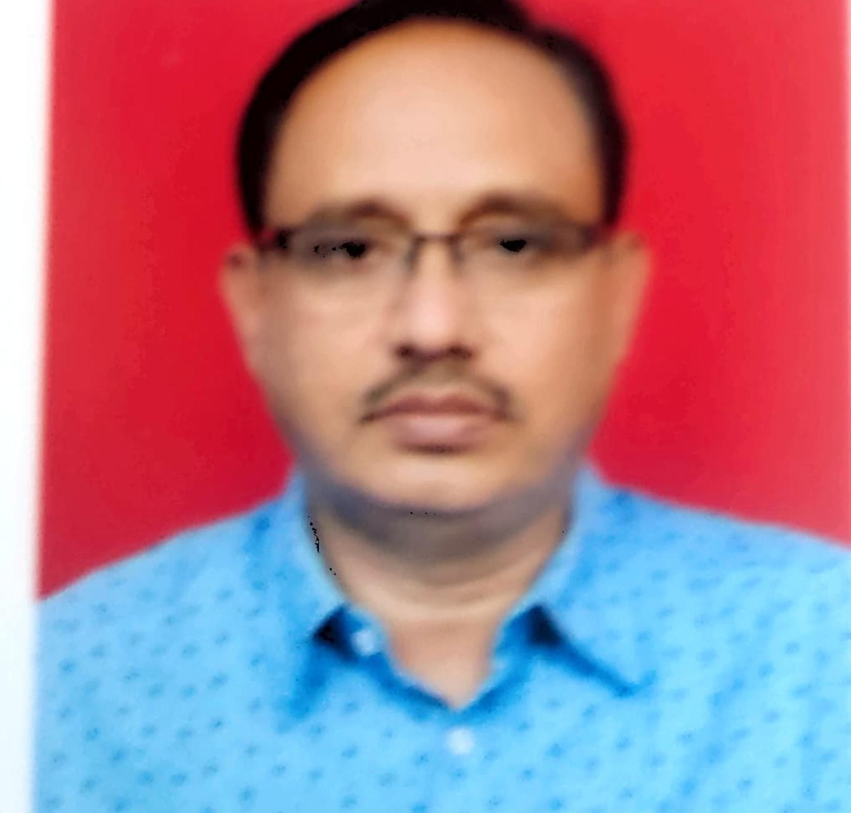
GOVERNMENT POLYTECHNIC ARVI FACULTY TRAINING INFORMATION
DEPARTMENT: MECHANICAL ENGINEERING DEPARTMENT

- Name of the faculty member : Mr. Vinod। Uttamrao Datir
- Designation : Selection Grade Lecture
- Date of Birth & Age : 19/07/1966,56 years
- Date of joining Tech Ed Dept : 14/09/2001
- Date of joining G P Arvi : 09/07/2023
- Address for correspondence : Dept.of Mech.Engg.,Govt. Polytechnic, Arvi. Distt: Wardha

- Mobile No.: 9422863707 email : vinod datir623@gmail.com
- Academic Qualification (Bachelor Degree onwards)
Sr.  No. | Degree Held | University | Year of passing | Specialization
1 | B.E. | Amravati University, Amravati | 1989 | Production Engg.
2 | M.E. | Jadavpur University, Kolkata | 1997 | Production Engg.

- Research Publication :
Paper published at International Conference on science and technology at Bangkok Thailand

- Details about training / seminars / conference etc
(From years 2018-19, 2017-18, 2016-17). 1) Training on Renewal sources of Energy (one week)
2) International Conference on science and technology at Bangkok Thailand (one week)
- Expert Lecture/Seminar delivered
(From years 2018-19, 2017-18, 2016-17)

Sr.  No. | Title of Lecture / Seminar | Date | Venue
1. | Carrier opportunities in Technical Education | 04/07/2017 | Shri. Deorao Dada High School Tiosa, Distt.  Amravati
2. | Carrier opportunities in Technical Education | 18/07/2018 | Shri Datta Meghe Instt. Of Engg and Tech.  Sawngi (Meghe) Wardha

- Workshop / Seminar Attended

(From years 2018-19, 2017-18, 2016-17)

Sr.  No. | Name of Workshop / Seminar Attended | Date | Venue | Days/Week
1 | On OBE and CO-PO mapping | 15/1/2022

- Training attended
(From years 2018-19, 2017-18, 2016-17)

Sr. No | Title | ISTE/MSBTE/DT E/AICTE/YASH ADA/NITTTR/O THER | Date | Venue | Days/Week
1 | Training on Renewal Energy sources | ISTE | 08/11/2017  to 19/12/2018 | Yashda Pune | 42 days

Signature

